USER MANUAL
Image Forensics SIEM Dashboard
Introduction
The “Image Forensics SIEM (Security Information and Event Management) Dashboard” is an advanced, automated toolkit for analyzing image authenticity and detecting tampering, manipulation, or synthetic generation. It comprises three distinct engines—the Physics Engine, AI Engine, and OSINT Engine—that run synchronously to pinpoint anomalies and generate a unified threat report.
System Requirements & Installation
Ensure you have the necessary dependencies installed:
- bash - pip install -r requirements.txt
To launch the application globally or within your local environment:
- bash - streamlit run app.py
Launching the Dashboard
Upon running the command above, a modernized, futuristic dark-themed web interface will open in your browser. The dashboard is divided into two primary areas:
- Case Management (Left Sidebar):
For evidence intake and analysis execution.
- Main Dashboard (Center Area):
Where all results, metrics, and visual maps are projected.

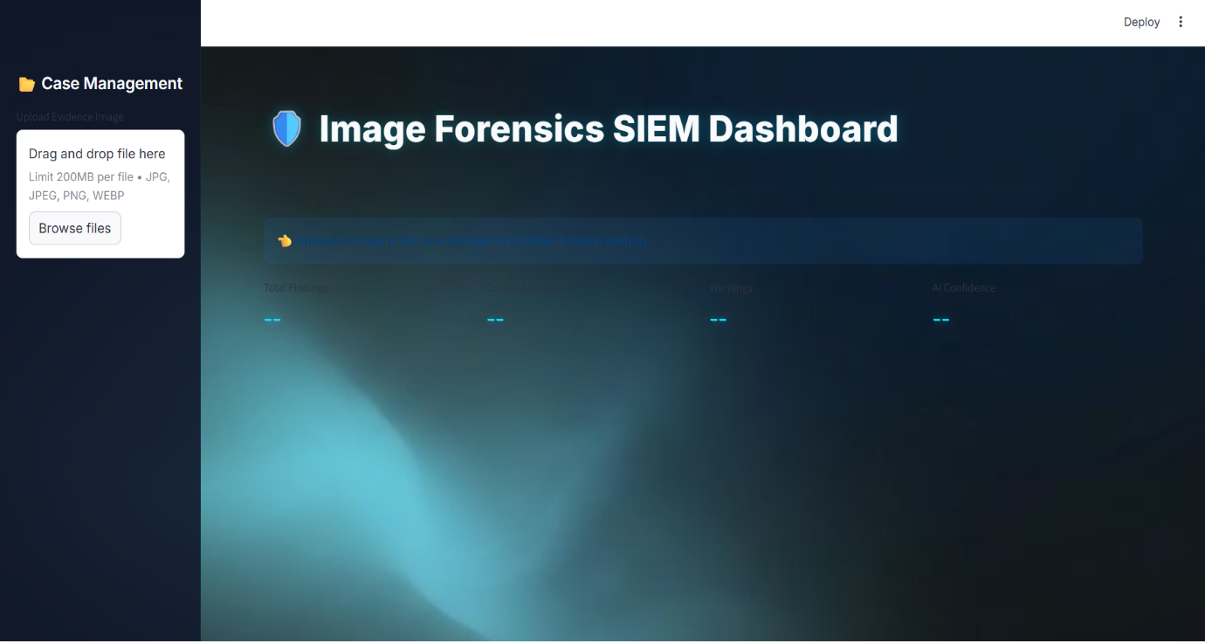
Fig 1 – Dashboard
How to Analyze an Image
- Expand the “Case Management” tab on the left sidebar.
- Click “Browse Files” to upload your Evidence Image. Supported formats include ‘.jpg’ , ‘.jpeg’ , ‘.png’ , and ‘.webp’.
- Once the image is uploaded, a thumbnail called “Evidence Subject” will appear.
- Click the “Run Forensic Analysis” button to initialize the pipeline.
- The system will Synchronously run the physics, AI, and OSINT engines. Wait for the success message: “Analysis Completed!”.
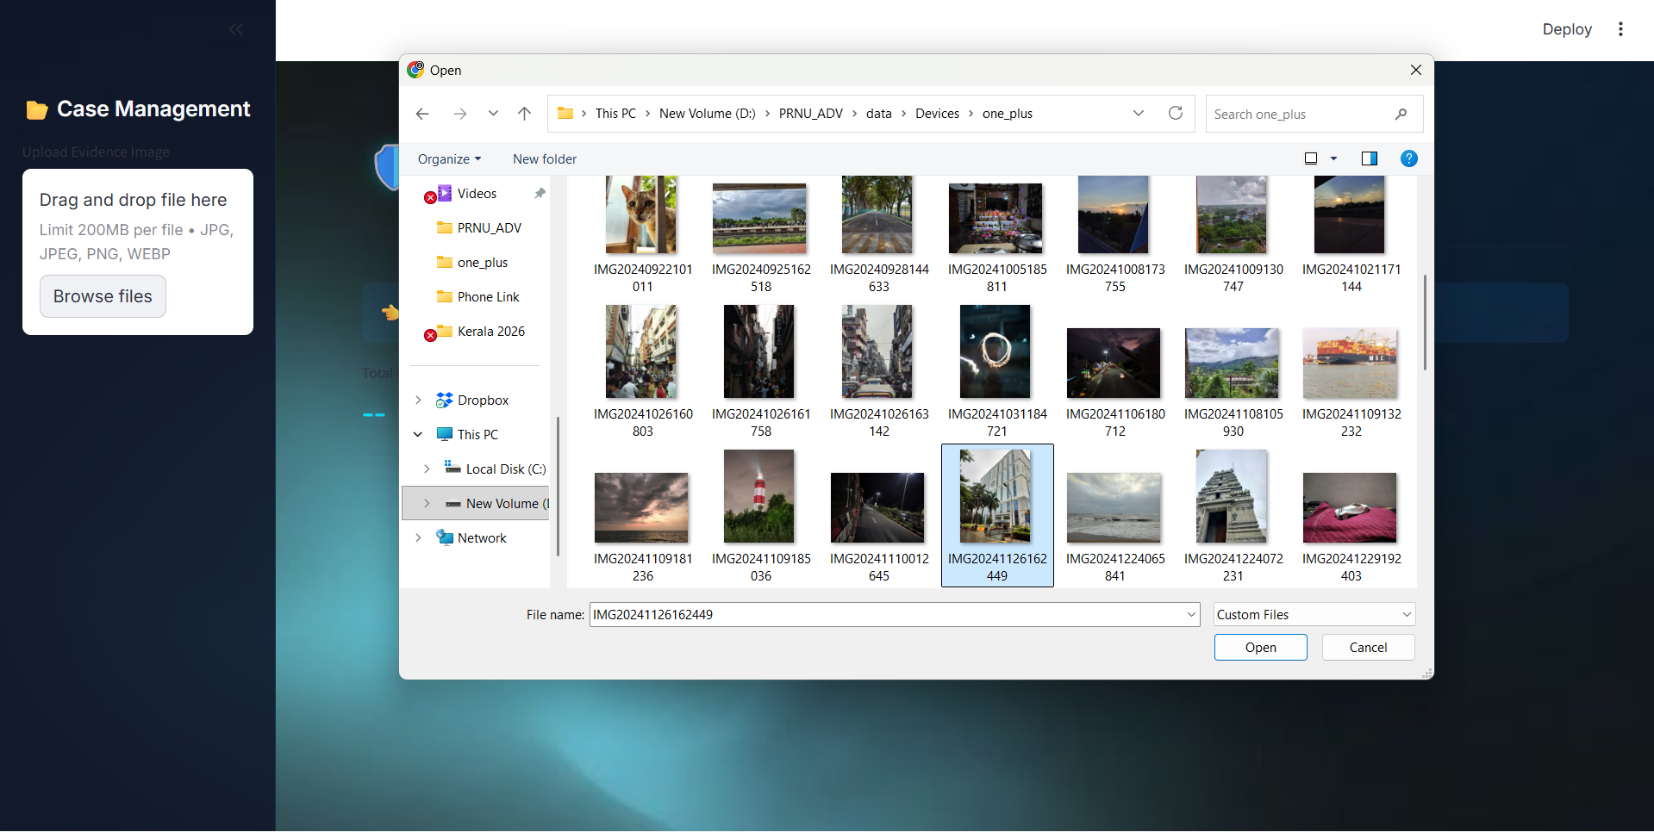


Interpreting the Dashboard Results
Once an image finishes processing, the Main Dashboard populates with detailed insights.
  - Executive Summary : A quick-glance metric board summarizes the analysis:
      - Total Findings: The aggregate amount of forensics alerts captured across all modules.
      - Critical Anomalies: High-Severity issues that strongly suggest tampering or Synthetic origin.
      - Warnings: Medium-severity events indicating suspicious characteristics requiring human review.
      - AI Confidence: The generative AI Confidence score, measuring the likeliness of the image being synthetic.
                - Visual Evidence Analysis: Displays your original, uploaded image. You can hover your cursor over the image to magnify specific regions (zoom-in functionality).
                - Forensic Alert Timeline: An interactive feed displaying color-coded alerts indicating the type and severity of findings:
- High (RED): Critical tampered regions, GENAI matching, Deepfake detections.
- Medium (Orange): Missing / manipulated metadata, irregular noise distractions.
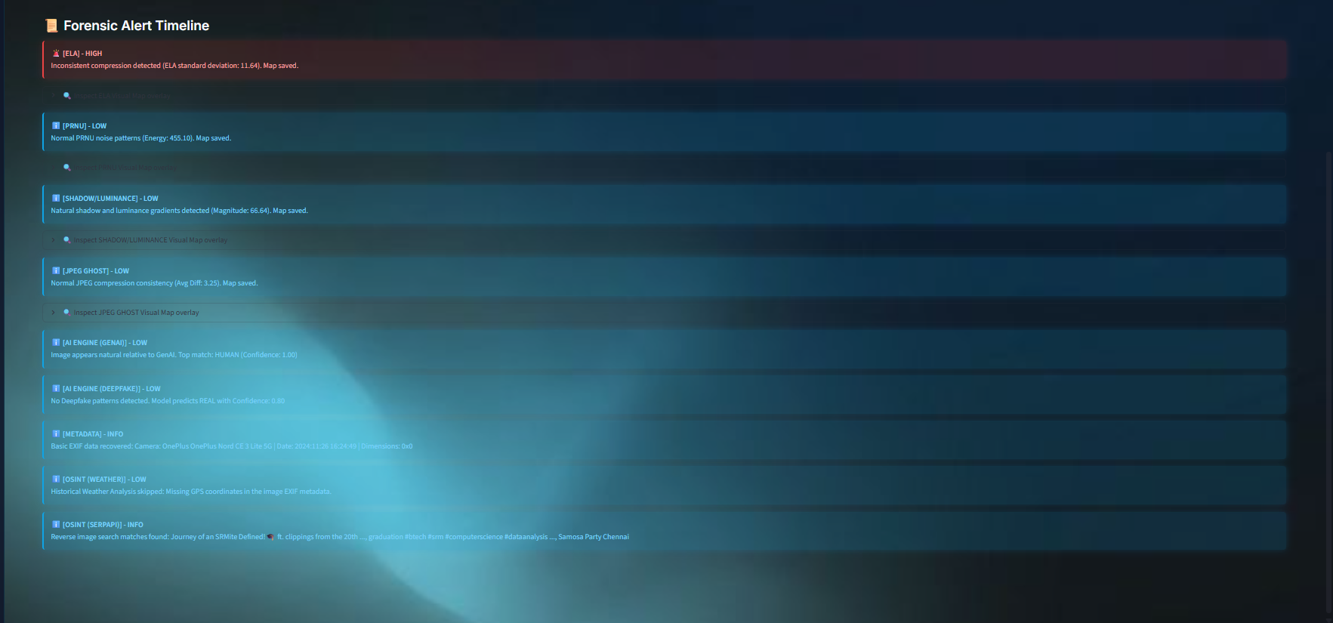
- Low (Blue): Standard logging, unmodified EXIF info, Weather metadata.

Core Engine Capabilities
- Physics Engine :
The physics engine breaks down image structure to expose pixel-level tampering:
- Error Level Analysis (ELA): Identifies inconsistent compression qualities across the image. Spliced objects often look drastically different in an ELA map.
- PRNU (Photo Response Non-Uniformity): Extracts wavelet noise mappings. It detects anomalous sensor noise clusters to determine if multiple camera sensors acquired different parts of the image.
- Shadow / Luminance Grading: Evaluates unnaturally smooth gradients that are often the hallmark of airbrushing or GAN (Generative Adversarial Network) outputs.
- JPEG Ghosting: Looks for double quantization by re-saving the image and finding inconsistent differential compressions characteristic of cropped/pasted areas.
- AI Engine :
Powered by locally executed or remote classification models:
  - GENAI Detection : Uses SDXL-detector models to identify imagery artificially composed by Midjourney, stable Diffusion, or similar generation models.
  - Deepfake / Face Swapping: Segregates faces and tests them against Deepfake-recognition weights, returning a direct confidence interval on the authenticity of the subject.
- OSINT Engine :
Extracts embedded traces and matches them with external data grids:
    - Metadata Extraction : Reads foundational EXIF profiles and highlights traces of software editing.
    - GPS & Geolocation : If GPS traits exist, the engine reverse-map the geographic coordinates and generates an interactive map.
    - Historical Weather Verification : Cross-references the coordinate and DateTime attributes with open-metro’s database. It checks to see if the weather conditions depicted in your image match the factual meteorological records of that specific hour.
    - Reverse Image Search : Safely pings out the image trace to find visual matches on the web to identify stolen assets or prior internet existence.
Troubleshooting & Best Practices
- Social Media Images: Images downloaded from modern social platforms like (WhatsApp, Facebook) are aggressively stripped of their EXIF data. Expect metadata found.
- False Positive in PRNU: Extremely low-light images with natural high-ISO grain may sometimes trigger the PRNU irregularity warning. Always cross-compare with the ELA maps.
- Engine Error : If an engine fails, check the alert timeline; the pipeline gracefully falls back and will emit an “Error” tag identifying the specific traceback without braking the rest of the application.

